**Thruster Report**

|  |  |
| --- | --- |
| **Thruster Ratio:** | **1.200** |
| **Magnetic Field:** | **265 mT** |
| **Anode Power:** | **559 W** |
| **Anode Current:** | **6.0 A** |
| **Anode Energy:** | **24021.5 J** |
| **Propellant:** | **Argon 0.499 mg/s** |

**Thruster Details: Nagoya magnet, LaB6 cathode, 1 mm orifice, copper anode, 80 mm internal diameter. CoM correction method: Anode Energy, Pre-offset 0.0 s, Post-offset 100.0 s, Cold-Gas thrust 0.1 mN**

|  |  |  |  |  |  |  |
| --- | --- | --- | --- | --- | --- | --- |
| Thrust | Thrust Eff. | ISP | Total DOF | Coverage Factor | Exp. Uncertainty | Std. Uncertainty |
| 10.2 mN | 18.7 % | 2084.8 sec | 17 | 2.09 | 3.0 mN | 1.4 mN |

**Thrust-Stand Uncertainty Components**

|  |  |  |  |  |  |  |  |
| --- | --- | --- | --- | --- | --- | --- | --- |
|  | Weights | Scale | Hysteresis | Repeatability | Noise | Offset | Drift |
| Value | 0.0 mN | 1.0 mN | 0.3 mN | 0.3 mN | 0.4 mN | 0.8 mN | 0.4 mN |
| DOF | 30 | 6 | 6 | 6 | 31 | 4 | 4 |

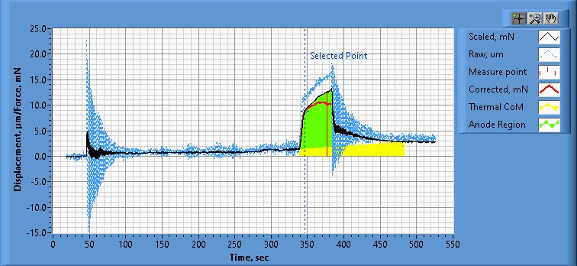

**Figure 1. Thrust Plot**

File Name: Philtech Data 2025.04.10_07.44.15.csv

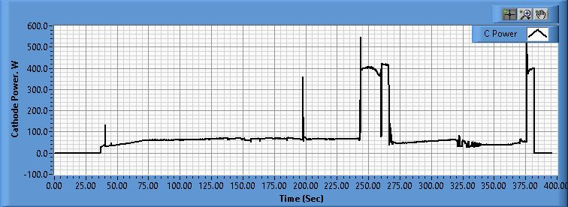

**Figure 2. Cathode Power Plot**

File Name: PSU C Data 2025.04.10_07.44.34.csv

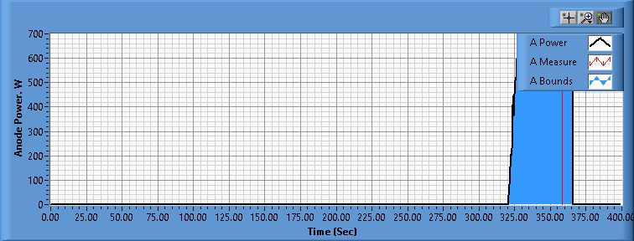

**Figure 3. Anode Power Plot**

File Name: PSU A Data 2025.04.10_07.44.33.csv

**Pre-Cal. Information**

File Name: Magnet_On_Flow_05_Philtech Data 2025.04.09_12.22.27.csv

Start/Stop times (24 h): 12:22:33 12:26:19

Sensitivity: 1.49 um/mN

|  |  |  |  |
| --- | --- | --- | --- |
| Offset | Drift | Scale Factor | Scale Std.Dev |
| 0.951 mN | -0.021 mN/s | 0.672 | 1.225 mN |

Plateau values:

|  |  |  |  |  |  |  |  |  |  |  |
| --- | --- | --- | --- | --- | --- | --- | --- | --- | --- | --- |
| Weight 0 | Weight 1 | Weight 2 | Weight 3 | Weight 4 | Weight 5 | Weight 4 | Weight 3 | Weight 2 | Weight 1 | Weight 0 |
| -0.3 mN | 22.6 mN | 39.3 mN | 59.5 mN | 79.6 mN | 101.0 mN | 79.8 mN | 59.5 mN | 39.2 mN | 21.8 mN | -0.3 mN |

**Post-Cal. Information**

File Name: Philtech Data 2025.04.10_07.44.15.csv

Start/Stop times (24 h): 07:54:09 07:57:59

Sensitivity: 1.46 um/mN

|  |  |  |  |
| --- | --- | --- | --- |
| Offset | Drift | Scale Factor | Scale Std.Dev |
| -1.888 mN | -0.034 mN/s | 0.685 | 1.138 mN |

Plateau values:

|  |  |  |  |  |  |  |  |  |  |  |
| --- | --- | --- | --- | --- | --- | --- | --- | --- | --- | --- |
| Weight 0 | Weight 1 | Weight 2 | Weight 3 | Weight 4 | Weight 5 | Weight 4 | Weight 3 | Weight 2 | Weight 1 | Weight 0 |
| -0.1 mN | 21.5 mN | 38.6 mN | 58.6 mN | 79.2 mN | 100.6 mN | 79.5 mN | 59.1 mN | 38.0 mN | 20.4 mN | -1.8 mN |